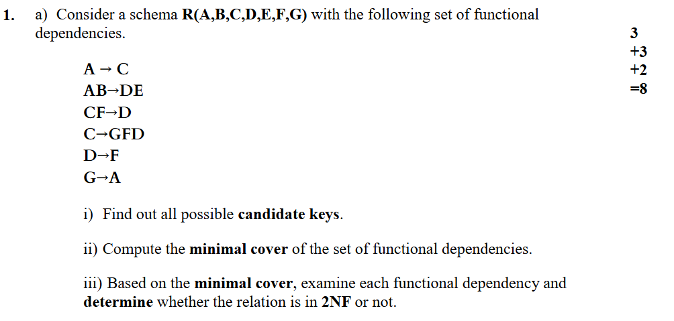
Spring 2025 - SOLUTION
Solution:
1)a) i)
here, alpha = {B}, beta = {E}
Attribute closure, (B)+ = {B} ; Not a super key
(AB)+ = {A,B,C,D,E,F,G} ; Super key
(BC)+ = {A,B,C,D,E,F,G} ; Super key
(BD)+ = {B,D,F}; Not Super key
(BF)+ = {B,F,}; Not super key
(BG)+ = {A,B,C,D,E,F,G} ; Super key
So, candidate key = {AB, BC, BG}
1)a) ii)
Decomposition | Trivial remove | Extraneous attribute removal | Extraneous Functional dependency removal
A → C  AB → D  AB → E  CF → D  C → G  C → F  C → D  D → F  G → A | A → C  AB → D  AB → E  CF → D  C → G  C → F  C → D  D → F  G → A | A→C  AB→D  AB→E  C→G  C→F  C→D  D→F  G→A | A→C ; (A)+ ={A}; keep  AB→D ; (AB)+ ={A,B, E}; Keep  AB→E ; (AB)+ ={A,B,D,F}; Keep  C→G ; (C)+ ={C, D, F}; Keep  C→D ; (C )+ = {C,G,A}; Keep  D→F ; (D)+ = {D} ; Keep  G→A ; (G) + = {G}; Keep
 | No trivial found | CF D is extraneous, according to three extraneous finding formulas. Rest is fine. | So, Minimal cover is = {A→C,AB→D,AB→E,C→G,C→D,D→F,G→A}
REMINDER
A relation is in Second Normal Form (2NF) if:
- It is in 1NF, and
- No partial dependency: A non-prime attribute (i.e. not part of any candidate key) is dependent on part of a composite primary key, but not on the whole key.
1)a)iii)
From, i candidate keys are = {AB, BC, BG}
Prime attributes (appear in at least one candidate key) : {A, B, C, G}
Non-prime attributes: {D, E, F}
Minimal cover is = {A→C, AB→D, AB→E, C→G, C→D, D→F, G→A}
Now, we have to check all FD from minimal cover.
A → C; A ⊂ AB (candidate key) and C is prime no violation
AB → D; AB is a full candidate key and D is non-prime no violation
AB E; AB is full candidate key and E is non-prime no violation
C G; C is a part of candidate key BC, and G is prime no violation
C D; C is a part of candidate key BC, but D is non-prime attribute and it violates the 2NF
D F; D is not in candidate key, and both D, F is non-prime attribute. no violation
G A; G is a part of Candidate key BG, and A is prime attribute. no violation
So, the relation R is not in 2NF, as Functional Dependency C D violates the 2NF.

Extra: check whether the relation is in 3NF:
REMINDER
For every functional dependency: $X→Y$
The relation is in 3NF if at least one of the following holds:
- X is a super key, OR
- Y is a prime attribute (part of some candidate key)
If neither is true → 3NF violation
Candidate Keys: { $AB, BC, BG \}$
Prime attributes: $\left\{A , B , C , G\right\}$
Non-prime attributes: $\left\{D , E , F\right\}$
Minimal cover is = {A→C,AB→D,AB→E,C→G,C→D,D→F,G→A}
Let’s check the all FD from Minimal cover:
A → C; A is not a super key; C is prime no violation
AB D; AB is candidate key no violation
AB E; AB is candidate key no violation
C G; G is a part of Candidate key BG no violation
C D; C is not a superkey and D is not a prime attribute or part of a candidate key violation
D F; D is not a superkey and F is non-prime attribute or part of a candidate key violation
G A; A is a part of candidate key. no violation
So, the relation R is not in 3NF, as Functional Dependency C D, DF violates the 3NF.
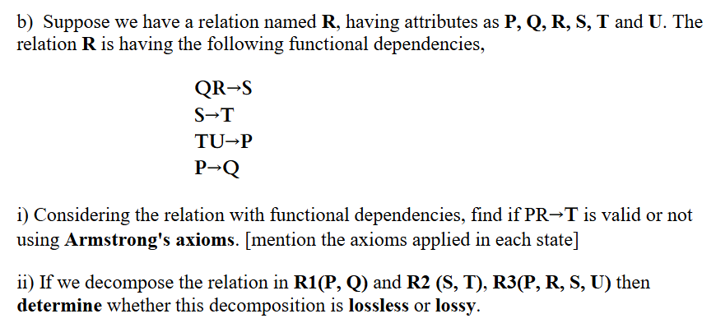

1)b) i)
We have to find the attribute closure of PR using given FD’s, If it provides T we will say it’s valid.
Attribute closure (PR)+ = {P, R, Q, S, T}; So, given functional dependency PRT is valid.
1)b) ii)
Given, Decomposed Relations
R1(P, Q)
R2(S, T)
R3(P, R, S, U)
Step 1: Identify common attributes
R1 ∩ R2 = ∅ → no common attributes → no need to check.
R1 ∩ R3 = {P}
R2 ∩ R3 = {S}
Step 2: lossless decomposition test
Note: If the intersection attributes is a key (determinant) in any of the table then it’s lossless, otherwise loosely.
R1 ∩ R3 = {P}; Is P a key for R1(P, Q)?
Yes, P determines Q, so P is a key for R1
R2 ∩ R3 = {S}; Is S a key for R2(S, T)?
Yes, S determines T, so S is a key for R2
Since each intersection is a key for one of the corresponding relations, then the decomposition is lossless.

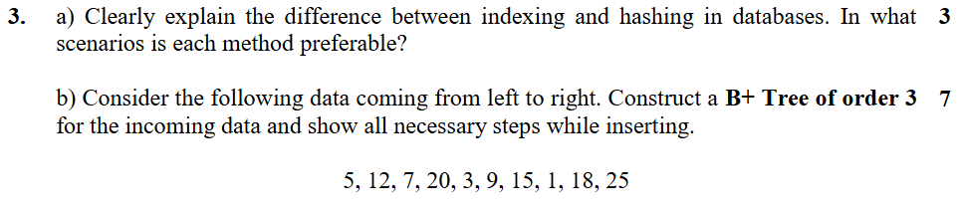
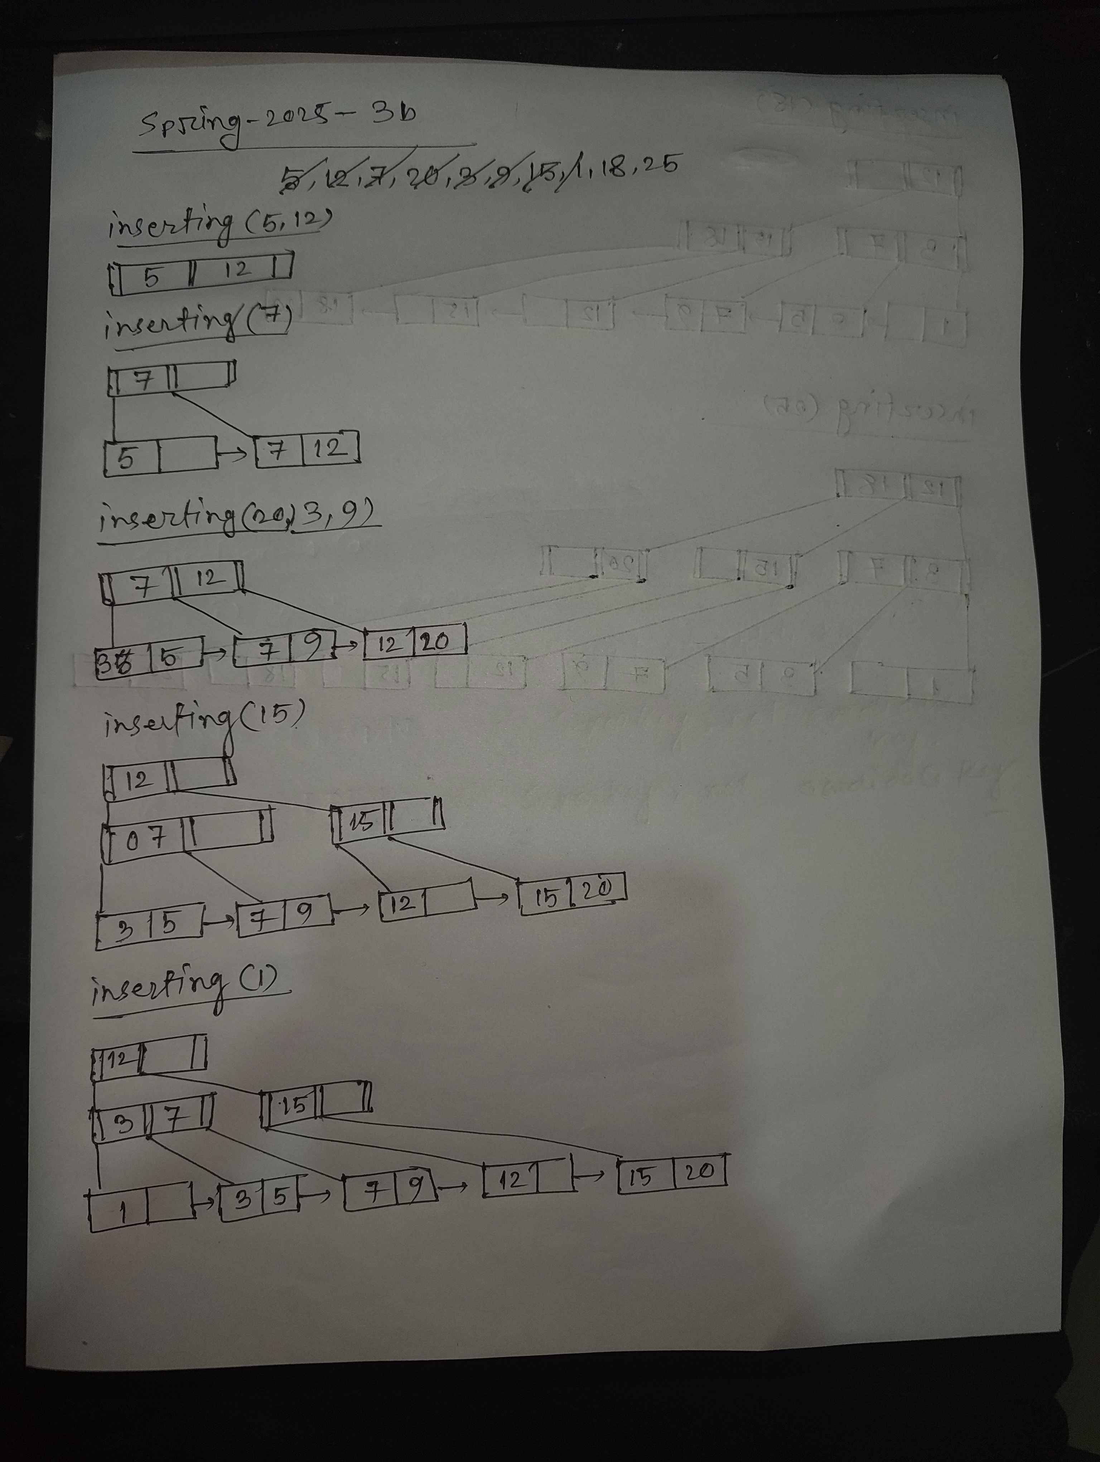
3)b)


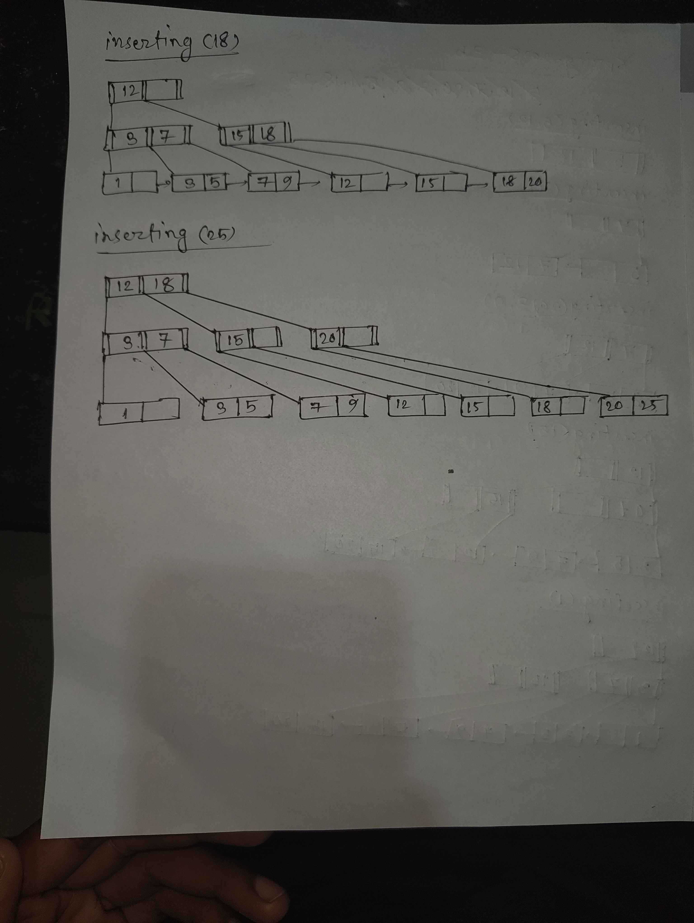

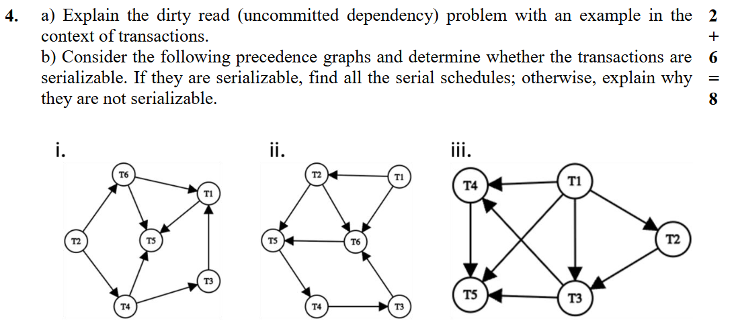
4) a)
A dirty read occurs when a transaction reads data that has been modified by another transaction that has not yet committed. If the other transaction is later rolled back, the data read by the first transaction becomes invalid or inconsistent.
- It’s called “uncommitted dependency” because one transaction depends on data that is not yet committed by another transaction.
- This problem occurs in low isolation levels, especially Read Uncommitted.

Let’s consider 2 transactions, T1 & T2:
T1 | T2
Write A := 500
 | Read A := 500
Rollback
 | A := 500+100

In transaction T1, the value of A becomes 500. Before T1 commits, transaction T2 reads this value of 500. If T1 later rolls back due to a system failure or error, the change to A is discarded. However, T2 has already read 500 into memory and may perform operations using it, which are now meaningless because the value of A never actually exists in the database.

